**DRV8256E based dual motor driver user guide**

**Introduction**

The DRV8256E based drivers are brushed motor drivers that operate from 4.5V to 30V supporting a wide range of output load currents for various types of motors and loads. The motor driver incorporates two DRV8256 ICs which enables controlling two motors using a single motor driver.

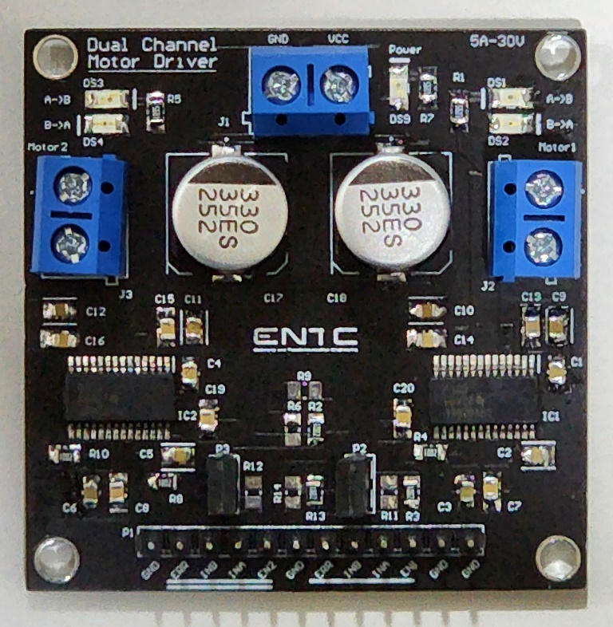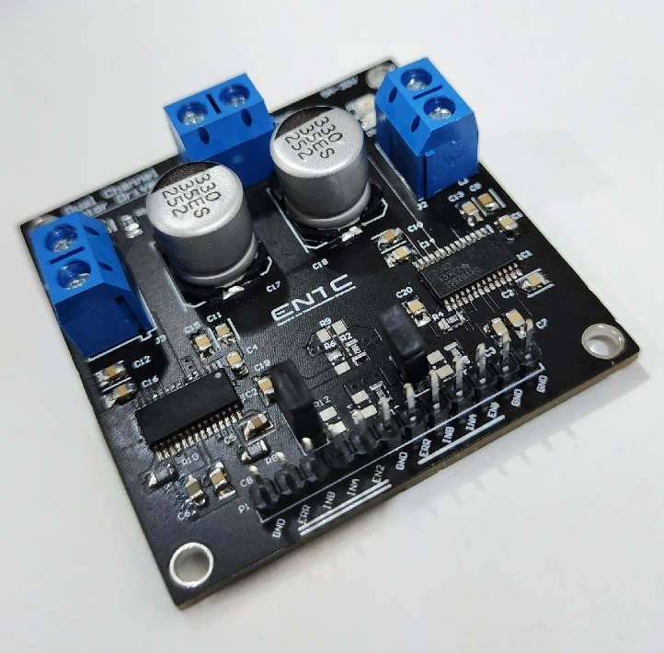

**Features**

The DRV8256E motor driver offers the following features:

* Dual H-bridge driver
* 4.5V to 30V operating voltage range
* 2.5A maximum continuous current rating per motor
* Thermal shutdown and overcurrent protection
* Enabling and disabling two motors separately using jumpers

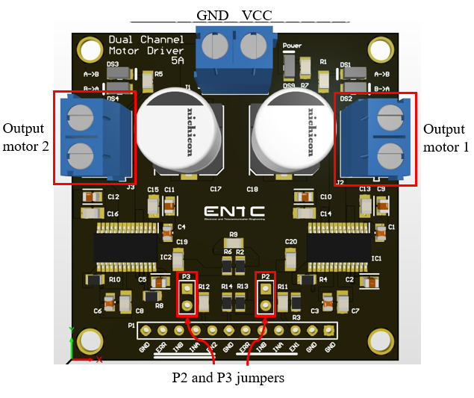

**Pinout**

|  |  |
| --- | --- |
| **Pin name** | **Description** |
| VCC | External power for motors. |
| GND | Ground pin. |
| ERR | Fault indication pin. Can detect if there is any error in the circuit. No need to connect it to operate the motor driver. |
| INA | Speed control pin. Give a PWM signal to control the speed of the motor |
| INB | Phase control pin. Motor rotating direction is controlled. |
| EN1,EN2 | Enable pins. Give logic level 1 (5V) to activate the motors |

**Bridge control**

Direction as well as the speed of the motor can be controlled by giving the following inputs to each motor pins of the motor driver. Note that the motor driver will not support break option and the motors will be working in drive/coast operation.

|  |  |  |  |  |  |
| --- | --- | --- | --- | --- | --- |
| **EN** | **INA** | **INB** | **OUT1** | **OUT2** | **Description** |
| 0 | X | X | Hi-Z | Hi-Z | Sleep mode: H-bridge disabled |
| 1 | 0 | X | Hi-Z | Hi-Z | H-bridge disabled |
| 1 | 1 | 0 | Low | High | Reverse mode |
| 1 | 1 | 1 | High | Low | Forward mode |

Speed of the motor can be controlled by giving a PWM signal to INA pin.

**Separate motor control feature**

P2 and P3 jumpers connect the two motors to input signals. The motor driver enables using two motors separately by disabling motors by disconnecting the P2 and P3 jumpers.

Please be aware of the following points when operating the motor driver.

* Ensure the current passing through the motor driver is less than the maximum current mentioned. Exceeding the maximum current will cause the motor driver to be damaged.
* As the motor driver does not support braking operation, you can manually break by changing the direction of motors. However, this will generate heat and can damage both motor driver and motor. If you are going to use fast breaking option, be mindful of the heat generated.